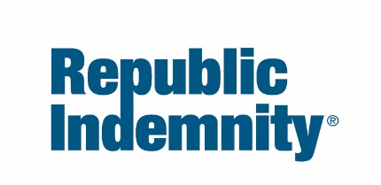

Hazard Communication Compliance Written Program

This is an example only. Employers are encouraged to develop their own program, specifically Hazard Communication Program, tailored to their operation and needs.

Date: [Type the date of last review]
[Name of Company], as required by California’s Hazard Communication (HazCom) Regulation (T8 CCR 5194) and/or the Federal Hazard Communication Standard, 29 CFR, Part 1910.1200, has developed a Hazard Communication Program to enhance our employees’ health and safety. The Hazard Communication Program manager, [type the person’s name or position here], has full authority and responsibility for implementing and maintaining this program.
As a company, we intend to provide information to all personnel on our worksite/worksites, including other employers and their employees, about the chemical hazards, in our workplace, associated hazards, and the control of hazards via our comprehensive Hazard Communication Program. This includes maintaining a current list of all hazardous chemicals on site, obtaining safety data sheets (SDSs) for each hazardous chemical on the list, ensuring all secondary containers are properly labeled, training employees regarding these hazards, and the steps they can take to protect themselves from exposure. Contractors working on our properties who bring hazardous chemicals are expected to follow these same requirements and have a written HazCom program of their own.

The following program outlines how we will accomplish this objective.

1. LIST OF HAZARDOUS CHEMICALS

[Type the name of person or position here] will prepare and keep current a list of all known hazardous chemicals present in our workplace that are in use or storage (see attached Hazardous Chemical List) and, at the same time, verify that we have the most current safety data sheets (SDSs). The product identifiers listed will match those on the corresponding container labels and SDSs. Specific information on each noted hazardous chemical can be obtained by reviewing the corresponding label and safety data sheet (SDS).

When new hazardous substances are introduced, [person/position] will review the new material and introduce employees to the new hazardous material/materials, in each area, at the next scheduled safety meeting.

2. SAFETY DATA SHEETS (SDSs)

Copies of safety data sheets (SDSs) for all hazardous substances to which employees of this company may be exposed, are kept in [location/locations]. [Person/position] will be responsible for obtaining and maintaining the safety data sheet system for the company.

[Person/position] will review incoming safety data sheets for new and significant health or safety information. He/She will see that any new information is passed on to the affected employees. Safety data sheets (SDSs) will be reviewed for completeness by [person/position]. If a SDS is missing or obviously incomplete, a new SDS will be requested from the manufacturer or distributor. If missing SDS is not received from the manufacturer within 7 days, a written request will be made to the manufacturer or distributor, and a copy forwarded to Cal/OSHA or Federal OSHA if no response from the manufacturer or distributor is received within 25 days.

Current safety data sheets (SDSs) may be maintained on electronic files, provided all employees know how to access this information and access is immediately available without having to navigate any barriers, or ask anyone for permission, and that the electronic file system has a battery backup system in place.

3. CONTAINER LABELING AND OTHER FORMS OF WARNING

It is the policy of this company that no container of hazardous substances will be released for use until the following label information is verified by [provide name of person or position]:

Original containers received from the manufacturer, distributor, and importer, are clearly labeled as to the contents and that they have the following information:
- Product Identifiers
- Signal words
- Hazard statements
- Pictograms
- Precautionary statements
- Name, address, and telephone number of the manufacturer, distributor, importer, or other responsible party.

To further ensure that employees are aware of the hazards of materials used in their work areas, it is our policy to label all secondary containers as well with the following information:
- Product Identifiers
- Signal words
- Hazard statements
- Pictograms
- Precautionary statements

The supervisor [provide name of person or position] will ensure that all containers, both original and secondary, are properly labeled with information above.

4. EMPLOYEE INFORMATION AND TRAINING

Employees are to attend a health and safety orientation that includes HazCom training set up by [type person’s name or position here] at the time of their initial assignment and whenever a new chemical hazard is introduced into the work area, and shall include information and training on the following specifics:
- Provide an overview of the requirements contained in the Hazard Communication Standard, including their rights under the standard or regulation.
- Inform employees of any operations in their work area where hazardous substances are present.
- Provide the location and availability of the written hazard communication program and safety data sheets (SDSs).
- Note the physical and health effects of the hazardous substances.
- Cite the methods and observation techniques used to determine the presence or release of hazardous substances in the work area.
- Provide how to lessen or prevent exposure to these hazardous substances through usage of engineering controls, work practices, and/or the use of personal protective equipment (PPE).
- Note steps the company has taken to lessen or prevent exposure to these substances.
- Provide emergency and first aid procedures to follow if employees are exposed to hazardous substances.
- Note how to read labels and review material safety data sheets (MSDSs) to obtain the appropriate hazard information needed for the situation.

Training will be documented via the attached Hazard Communication Employee Training Roster and include the following items:
- Operations where hazardous chemicals are present.
- Location and availability of the written Hazard Communication Program, including the list of hazardous chemicals and safety data sheets.
- Methods and observations that may be used to detect the presence or release of a hazardous chemical in the work area.
- The physical, health, simple asphyxiation, combustible dust, and pyrophoric gas hazards, as well as hazards not otherwise classified, of the chemicals in the work area.
- The measures employees can take to protect themselves from these hazards, including specific procedures implemented to protect employees from exposure to hazardous chemicals.
- Details of the Hazard Communication Program, including an explanation of the labels received on shipped containers and the workplace labeling system, safety data sheets, and how employees can obtain and use the appropriate hazard information.
- Employee rights:
- To personally receive information regarding hazardous chemicals to which they may be exposed.
- For their physician or collective bargaining agent to receive information regarding hazardous chemicals to which the employee may be exposed.
- Against discharge or other discrimination due to the employee’s exercise of the rights afforded pursuant to the provisions of the Hazardous Substances Information and Training Act.

5. HAZARDOUS NON-ROUTINE TASKS

Periodically, employees are required to perform hazardous non-routine tasks. Prior to starting work on such non-routine projects, each affected employee will be given information by their supervisor about hazards to which they may be exposed during such an activity. This information may include:
- Specific hazards
- Personal protective equipment and/or safety measures which must be utilized to reduce exposure
- Other measures the company has taken to lessen the hazards, which may include ventilation measures, respirator use, presence of another employee for the tasks, and any emergency procedures

Example of non-routine tasks performed by an employee of this company include the task and the hazardous substance:

Task Hazardous Substance
Cleaning sewage tanks Sodium Hydroxide

6. HAZARDOUS SUBSTANCES IN LABELED OR UNLABELED PIPES — (IF APPLICABLE)

Above-ground pipes transporting hazardous chemicals (gases, vapors, liquids, semi-liquids, and plastics) will be identified in accordance with 29 CFR Part 1910.6(e)(6), which incorporates ANSI A13.1-56 (scheme for the identification of piping systems) by reference for 29 CFR Part 1910.253 (d) (4) (ii), Oxygen and Fuel Gas Cutting and Welding; 29 CFR part 1910.126 (a)(3)(iii), Pulp Mills; 29 CFR Part 1910.262 (c)(7), Textile Plants; 29 CFR Part 1910.106 (h)(4)(ii)(c) Processing Plants, and for California with T8 CCR, section 3321, "Identification of Piping."

Before employees enter the area and initiate work on or near pipes, [type the person’s name or position here] will inform them of:
- The location of the pipe or piping system or other known safety hazard
- The chemicals in the pipe
- Potential hazards
- Safety precautions

7. INDEPENDENT CONTRACTORS AND TEMPORARY EMPLOYEES WORKING IN OUR WORKPLACE

To ensure that outside contractors work safely at our workplace and to protect our employees from chemicals used by outside contractors, [type the name of the person, position, or department here] is responsible for arranging two-way access of the following information with respect to contractors or other employers in our workplace:
- Hazardous chemicals, including Proposition 65 chemicals, to which they may be exposed while on the job site as well as chemicals they will be bringing into the workplace. To this end, we will provide contractors with information on our labeling system and access to SDSs.
- Precautions and protective measures the employees may take to minimize the possibility of exposure.
Should we use the services of a temporary employment service, we will treat their employees as if they are ours and include them in our Hazard Communication Program accordingly. Employees are to contact [type name of person or position here] if they have questions about this plan or wishes to review it. Our plan will be maintained by [type name of person or position here] to ensure that the policies are carried out and the plan is understood.
[Signature of Owner or Top Management Representative]

(ATTACHEMENT A) Sample Hazardous Chemical List
Hazardous Chemical  (Product identifier matches  SDS and label) | Operation/Work Area | SDS (date)

(ATTACHMENT B) Sample Employee Hazard Communication Training Roster
Content of the training will be as outlined in our written HazCom Program.
Date: [enter date] Department: [enter department name]
Name and title of person conducting the training: [enter name of instructor]
☐ Initial training (reference attached training topic checklist)
☐ Repeat training
☐ Training on newly introduced chemical Product identifier(s): [enter product identifier]
Employee Name | Signature

Prop 65: California employers must determine whether any of the hazardous chemicals from their chemical inventory are subject to Proposition 65 requirements. To obtain this updated list of chemicals, call Office of Environmental Health Hazard Assessment (OEHHA) by phone at 916-445-6900 or subscribe to Division 2 of title 27, California Code of Regulations, beginning with section 25000, from Barclays Law Publishers.

(ATTACHMENT C) Labels and Pictograms
The following is derived from the federal OSHA Brief Labels and Pictograms and QuickCard Standard Pictogram, and outlines what information must be present in every label.
Label Elements
The following elements are required on labels of hazardous chemicals:
- Name, Address, and Telephone Number of the chemical manufacturer, importer, or other responsible party.
- Product Identifier is how the hazardous chemical is identified. For example, this could be the chemical name, code number, or batch number. The same product identifier must be both on the label and in section 1 of the SDS.
- Signal Words are used to indicate the relative level of severity of the hazard and alert the reader to a potential hazard on the label. There are only two words used as signal words, “danger” and “warning.” Within a specific hazard class, “danger” is used for the more severe hazards and “warning” is used for the less severe hazards.
- Hazard Statements describe the nature of the hazard(s) of a chemical, including, where appropriate, the degree of hazard. For example: “Causes damage to kidneys through prolonged or repeated exposure when absorbed through the skin.”
- Precautionary Statements describe recommended measures that should be taken to minimize or prevent adverse effects resulting from exposure to the hazardous chemical or improper storage or handling. There are four types of precautionary statements:
◦ Prevention (to minimize exposure)
◦ Response (to provide emergency response and first-aid in case of accidental spillage or exposure)
◦ Storage
◦ Disposal
- Pictogram(s)
Environment Skull
Flame Over Circle Non Mandatory and Crossbones
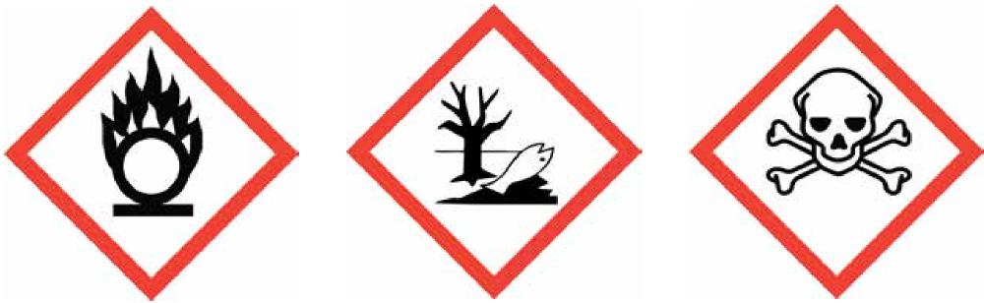
- Oxidizers • Aquatic Toxicity • Acute Toxicity (fatal or toxic)

Health Hazard Flame Exclamation Mark
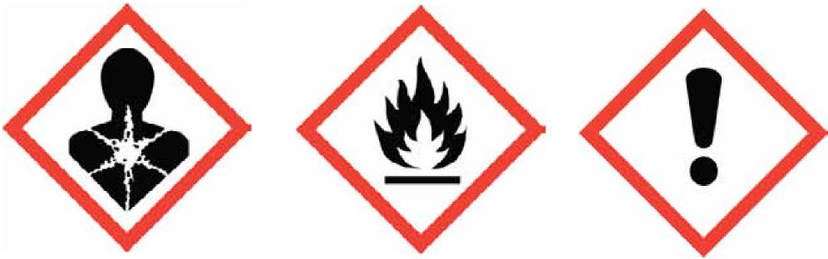
- Carcinogen  - Mutagenicity  - Reproductive Toxicity  - Respiratory Sensitizer  - Target Organ Toxicity  - Aspiration Toxicity | - Flammables  - Pyrophorics  - Self-Heating  - Emits Flammable Gas  - Self-Reactives  - Organic Peroxides | - Irritant (skin and eye)  - Skin Sensitizer  - Acute Toxicity (harmful)  - Narcotic Effects  - Respiratory Tract Irritant  - Hazardous to Ozone Layer (Non-Mandatory)

Gas Cylinder Corrosion Exploding Bomb
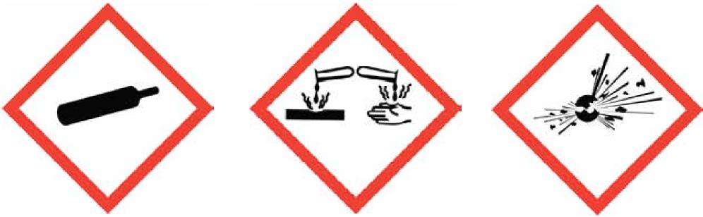
- Gases Under Pressure • Skin Corrosion/Burns • Explosives
- Eye Damage • Self-Reactives
- Corrosive to Metals • Organic Peroxides
Supplementary Information
The label producer may provide additional instructions or information that it deems helpful. It may also list any hazards not otherwise classified under this portion of the label. This section must also identify the percentage of ingredient(s) of unknown acute toxicity when it is present in a concentration of 1% or more (and the classification is not based on testing the mixture as a whole).
An example of an item that may be considered supplementary is the personal protective equipment (PPE) pictogram indicating what workers handling the chemical may need to wear to protect themselves. For example, the Hazardous Materials Identification System (HMIS) pictogram of a person wearing goggles may appear here. Other supplementary information may include directions of use, expiration date, or fill date, all of which may provide additional information specific to the process in which the chemical is used.
Pictograms are graphic symbols used to communicate specific information about the hazards of a chemical. On hazardous chemicals being shipped or transported from a manufacturer, importer, or distributor, the required pictograms consist of a red square frame set at a point with a black hazard symbol on a white background, sufficiently wide to be clearly visible.

SAMPLE LABEL
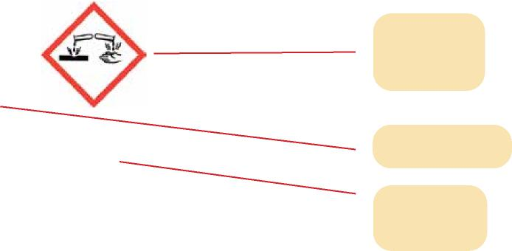
Product Identifier
Product name: XYZ Cleaner
Batch #: 225
CAS# 123-45-6789
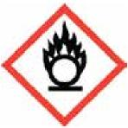
Hazard Pictograms
Danger
May cause fire or explosion; strong oxidizer
Causes severe skin burns and eye damage
Signal Word
Keep away from heat. Keep away from clothing and other combustible materials. Take any precaution to avoid mixing with combustibles. Wear protective neoprene gloves, safety goggles, and face shield with chin guard. Wear fire/flame-resistant clothing. Do not breathe dust or mists. Wash arms, hands, and face thoroughly after handling. Store locked up. Dispose of contents and container in accordance with local, state, and federal regulations.
Hazard Statement
First Aid:
Precautionary Statements
IF ON SKIN (or hair) or clothing: Rinse immediately contaminated clothing and skin with
plenty of water before removing clothes. Wash contaminated clothing before reuse.
IF IN EYES: Rinse cautiously with water for several minutes. Remove contact lenses, if
present and easy to do. Continue rinsing.
IF INHALED: Remove person to fresh air and keep comfortable for breathing.
IF SWALLOWED: Rinse mouth. Do NOT induce vomiting.
Immediately call poison center.
Specific Treatment: Treat with doctor-prescribed burn cream.

Fire:
In case of fire: Use water spray. In case of major fire and large quantities: Evacuate area.
Fight fire remotely due to the risk of explosion.

Company Name
Address
City State___
Postal Code Country

Supplier Identification
Directions for Use

Fill weight: Lot Number:
Gross Weight: Fill Date_
Expiration Date:
Prop 65 information:

The guidelines provided in this program are only intended to provide an overview of some of the more important steps that can be taken by management to establish a safe workplace. The guidelines are not considered exhaustive of all measures and controls that can be implemented by management to address all potential loss or injury producing causes. Ultimately it is the responsibility of management to take the necessary steps to provide for employee and customer safety. It is not intended as an offer to write insurance for such conditions or exposures. The liability of Republic Indemnity Company of America and its affiliated insurers is limited to the terms, limits and conditions of the insurance policies underwritten by any of them. © 2022 Republic Indemnity Company of America, 4500 Park Granada, Suite 300, Calabasas, CA 91302-1667.

